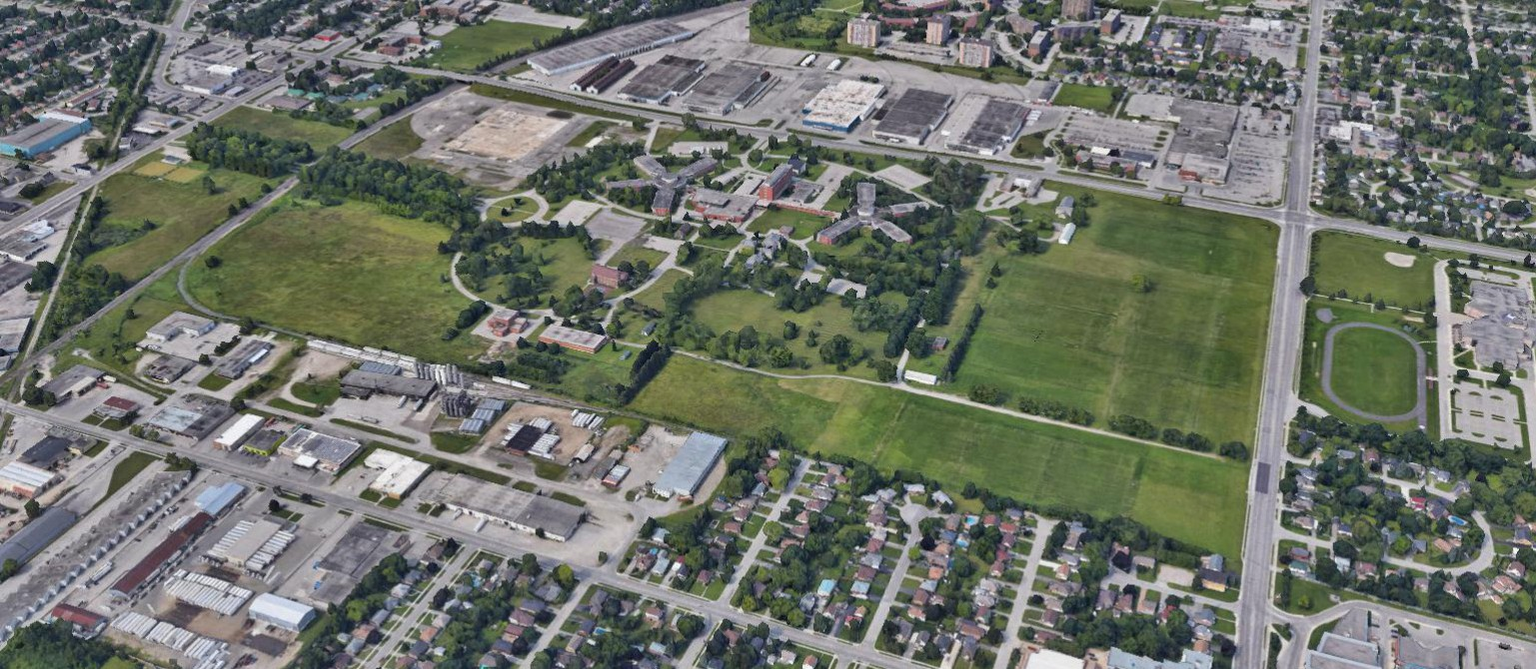
N

850 HIGHBURY AVENUE NORTH | LONDON, ONTARIO
COMMUNITY INFILL
D E V E L OP M E N T OP P OR T U N I T Y

DAVID COUSINS
FOR SALE - REVISED OFFERING
±162.26 ACRES
±144.00 ACRES
Sales Representative 519 286 2006
david.cousins@cbre.com

DAVID YANOSHITA
Sales Representative 519 286 2020
david.yanoshita@cbre.com

